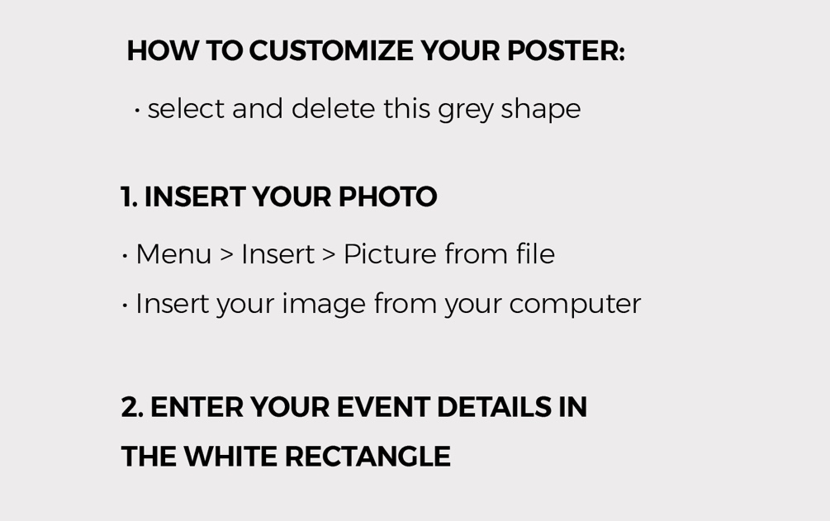

Event Title
Where:
When:
Register:

